**Online File Management System**

**Team Members: Wei and Yas**

A file management system is a computer program that provides a user interface to manage files and folders. Some file management systems provide network connectivity via protocols, such as FTP, NFS, SMB or WebDAV.

Online File Management System that we will design allow a user to login the system recognized the user access level. There will be the admin and the user access levels. The admin level can add, delete, block users’ account and modify their access level, as well as reset users’ password. The admin will basically manage the users and view users’ activities. The user level can completely manage all files. They are authorized to create/add, delete, upload, download, view and rename files.

The function of the system is shown below:

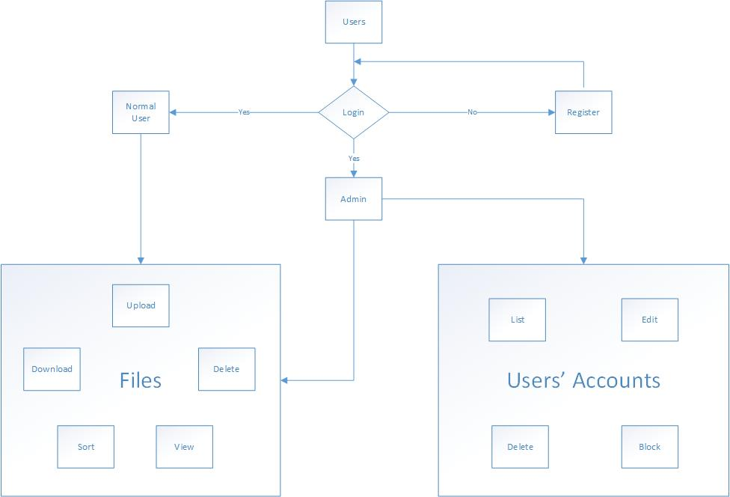

The system that we design will include two main pages, and one is the login and register page, the other one is the main page.

The login and register draft page is shown below:

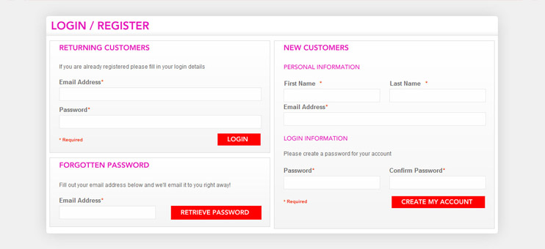

The main page is shown below:

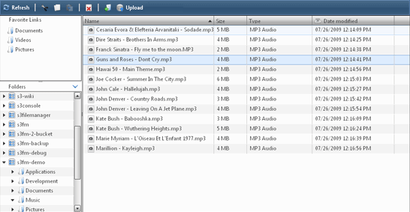

The code that we will develop will include some URLs, the list is shown below:

* /login
* /register
* /passwordreset
* /uploadfile
* /storage?sortby=size – view all files
* /admin/users/list
* /admin/users/edit
* /admin/users/delete
* /admin/users/block … later
* /downloadfile/:fileid
* /deletefile/:fileid
* /renamefile/:fileid
* /logout

The database that we will use is shown below:

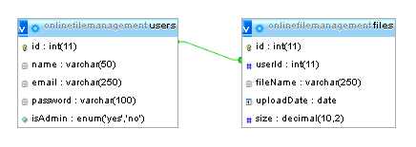

The technologies that we will use are shown below:

* Flash Messages
* File/Photo Upload
* Administration Panel